Software Career Day

When: Thursday July 28th 9am-noon

Goals: Introduce high school students to a career in the software industry along with a crash course in some basic programming

Location: Software & Services, 1120 S. Pointe Parkway, Shreveport LA 71105

Take Knight Street (off of Shreveport-Barksdale near the Wal-mart) and then turn onto S. Pointe Parkway, our building is about half way down S. Pointe Parkway

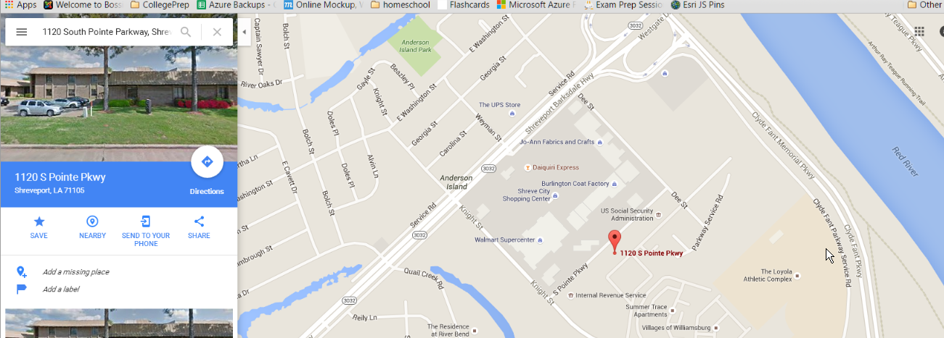

When to arrive: Arrive 5-10 minutes early, we’d like to start promptly at 9am. Proceed to the Building A (it’s the main building facing Knight Street, you’ll go to the Building A entrance). You can always call me if you get lost (318-470-0269)

What to wear: informal comfortable attire. Shorts and T-shirts are ok.

What to bring: if you want to take notes, bring something for that. You shouldn’t need anything else.